AWS-LAMBDA

Title
Event-Driven File Upload Monitoring Using AWS Lambda and S3

Objective
The objective of this task is to understand how AWS Lambda works in an event-driven architecture by automatically triggering a Lambda function whenever an object is uploaded to an Amazon S3 bucket. The task demonstrates how Lambda executes code without manual intervention and logs execution details for monitoring.

Prerequisites
Before starting this task, the following are required:
- An active AWS account
- Basic understanding of Amazon S3
- Basic understanding of AWS Lambda
- AWS Management Console access
- An S3 bucket created in the same AWS region as Lambda
- IAM permissions to create:
  - S3 buckets
  - Lambda functions
  - CloudWatch logs

STEP-BY-STEP-IMPLIMENTATION:
Go to AWS console and search for lambda

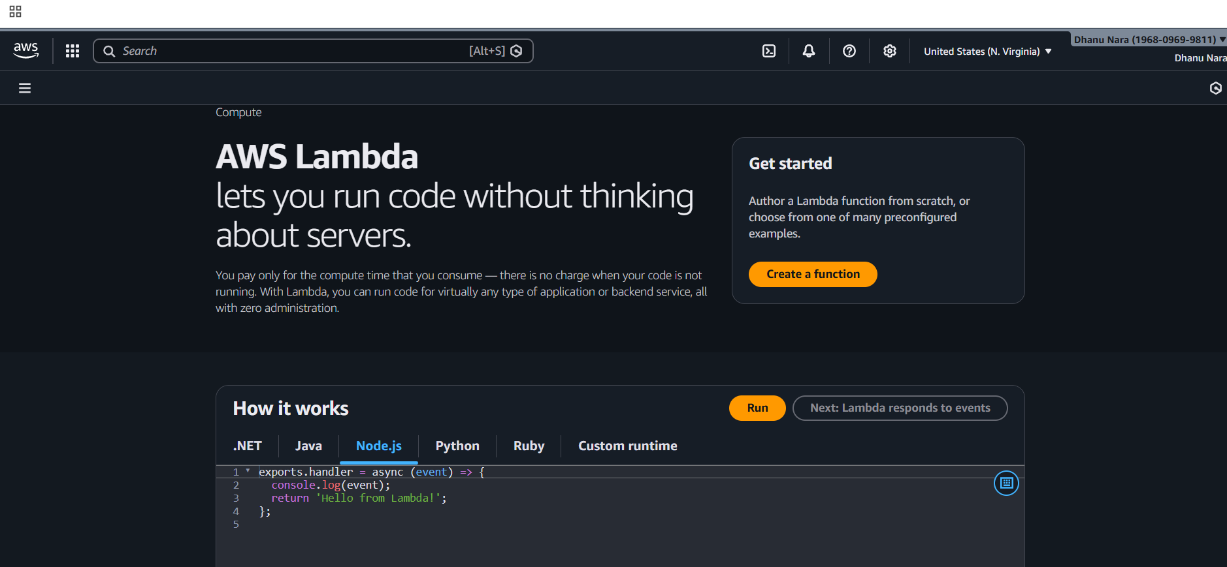
Click on create function
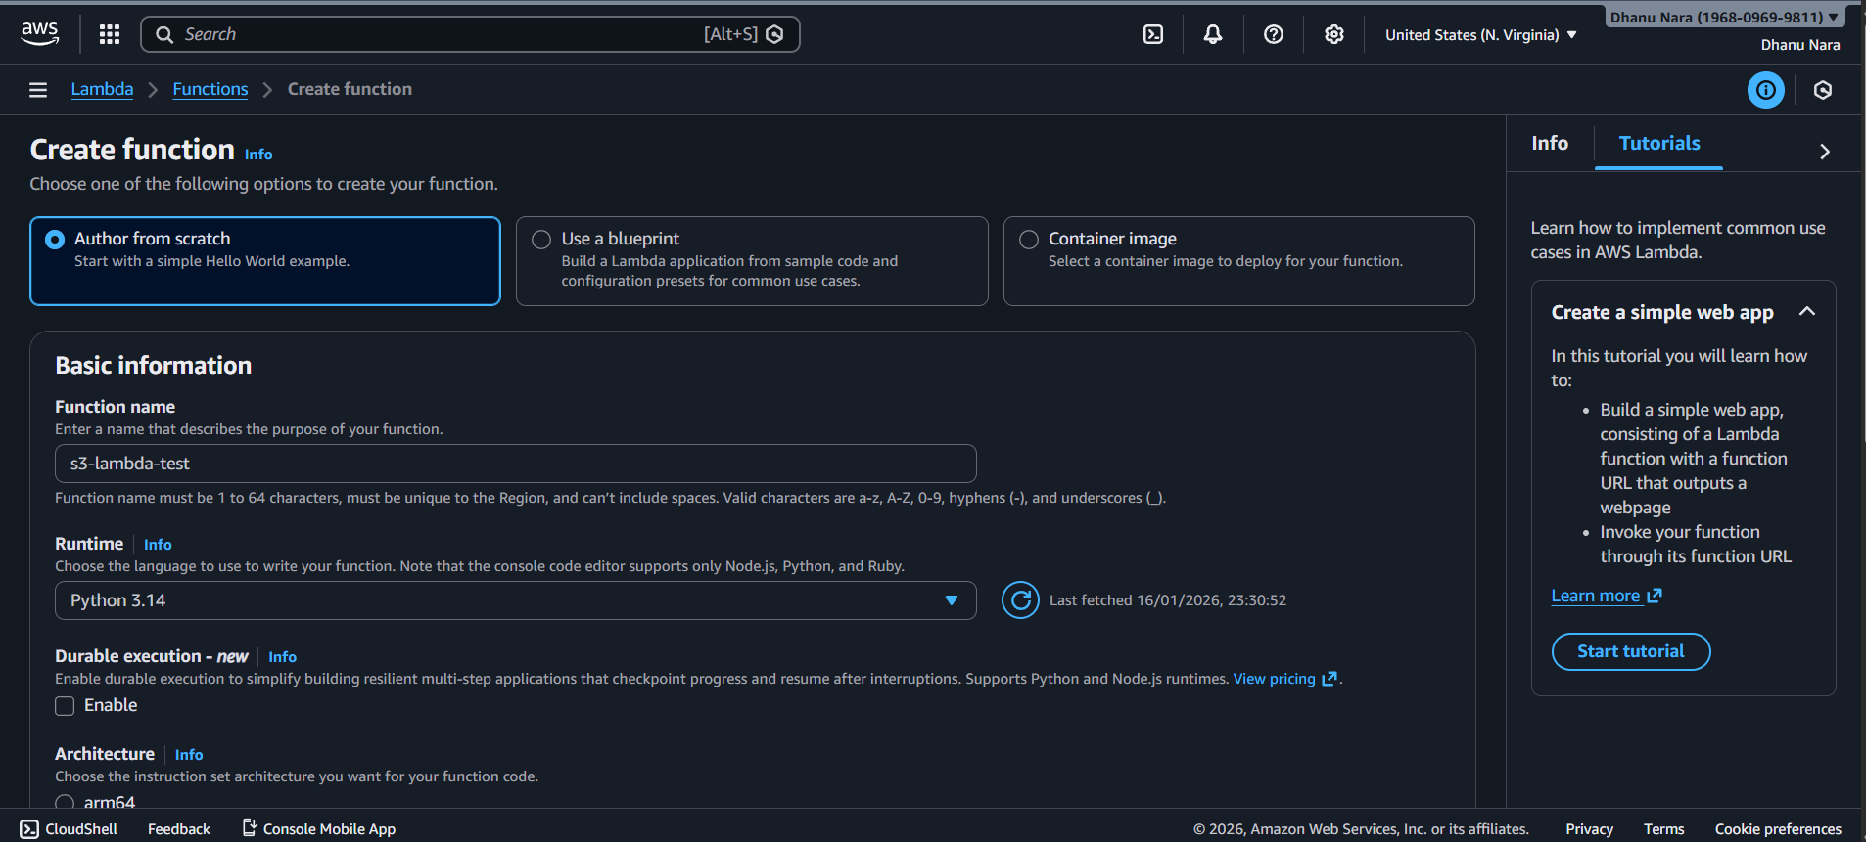
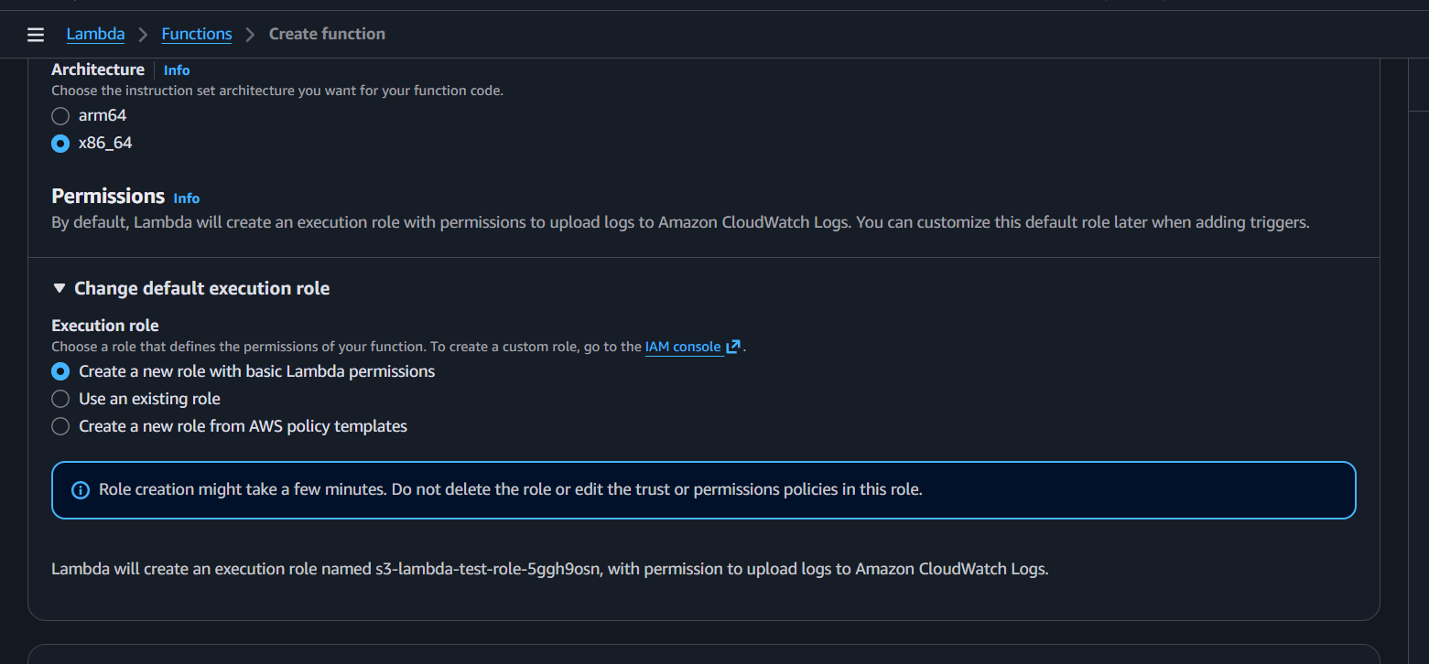
1️⃣ S3 sends an event when a file is uploaded.
2️⃣ Lambda starts running from lambda_handler.
3️⃣ The code reads the bucket name and file name from that event.
4️⃣ print() writes those details to CloudWatch logs.
5️⃣ Lambda finishes and stops.

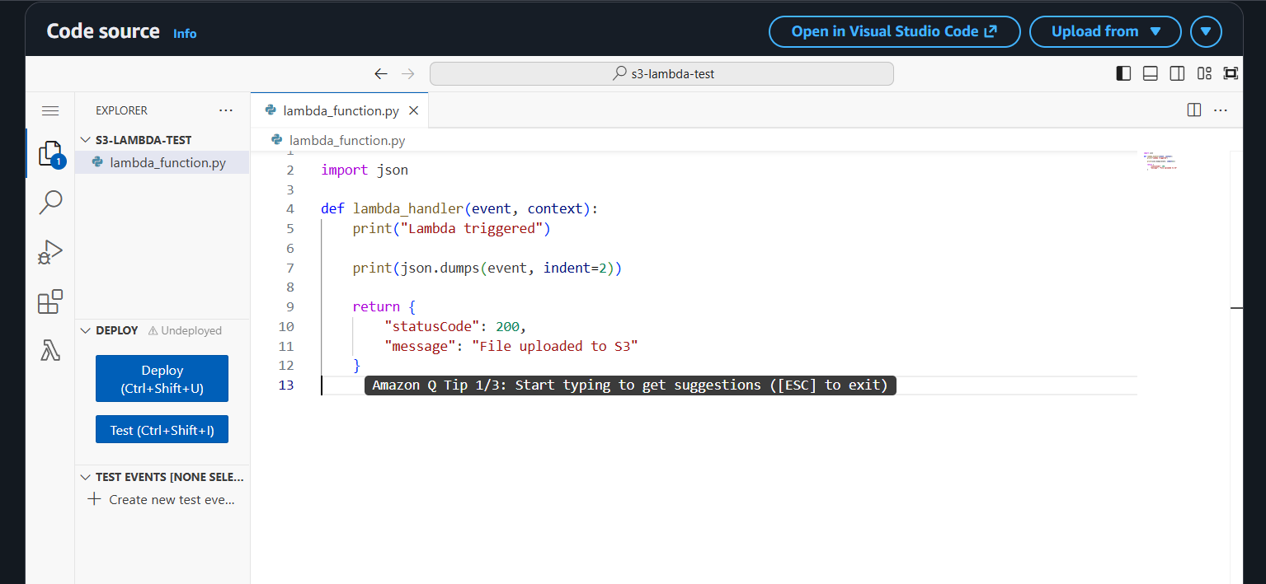

Create a bucket
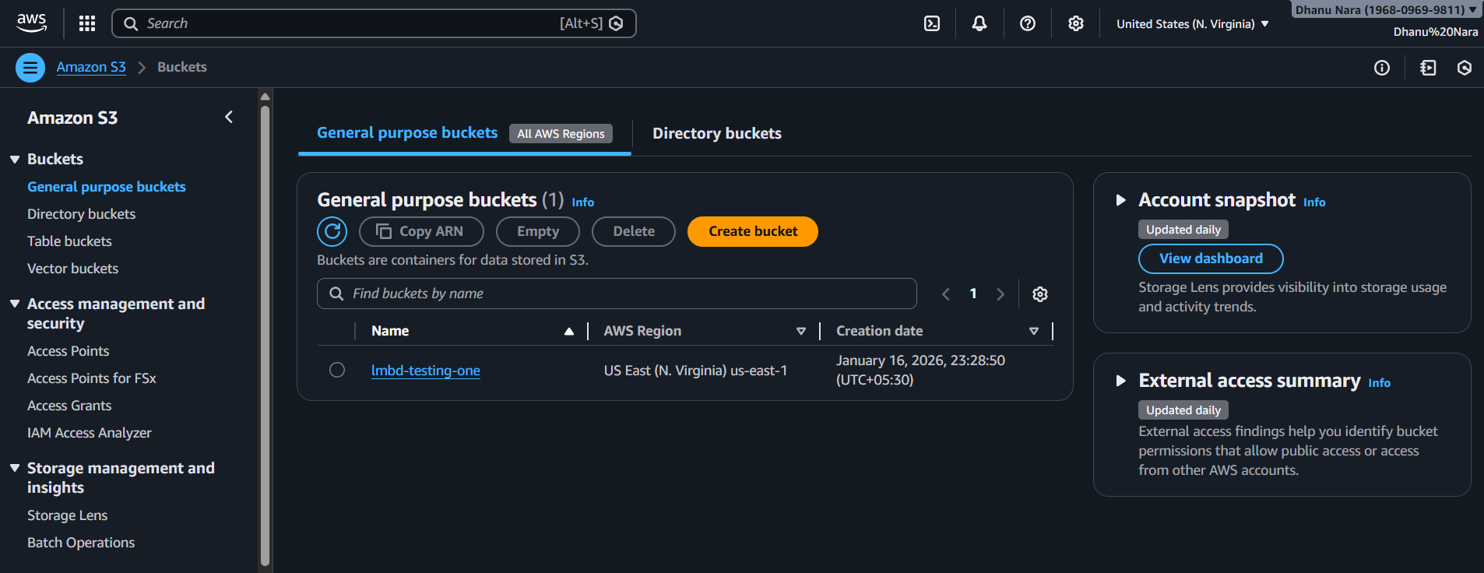
Now go to add trigger and give the credentials

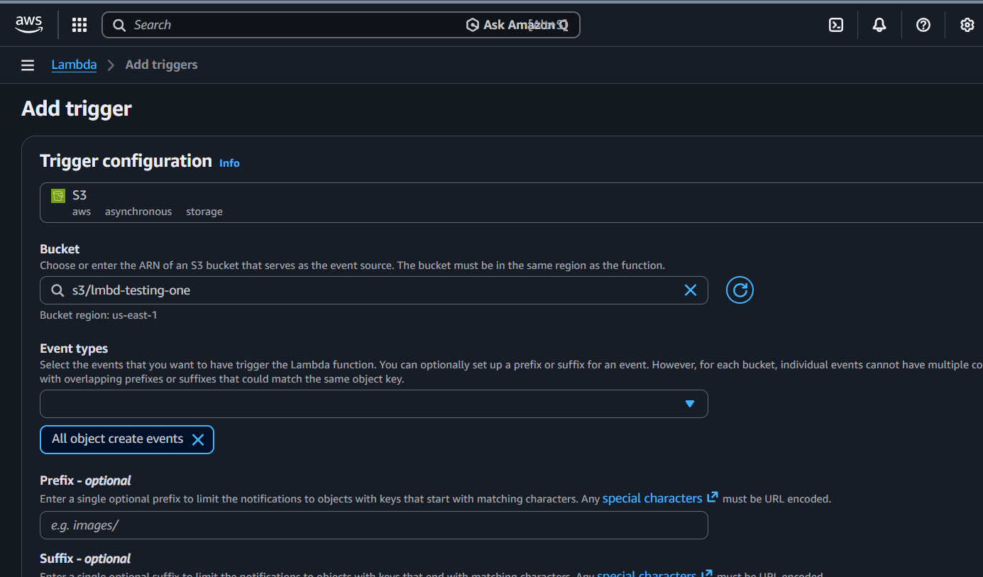
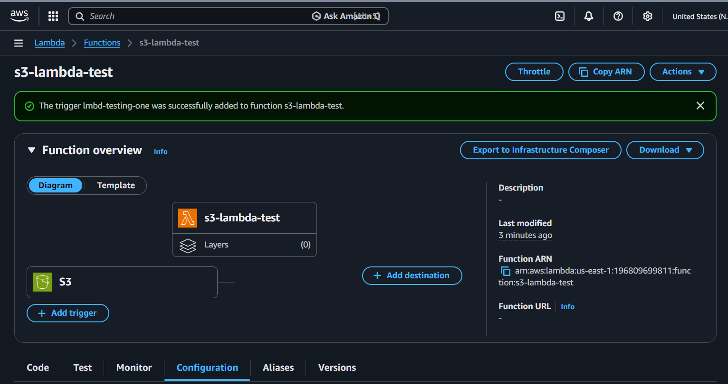
Upload a file in the bucket
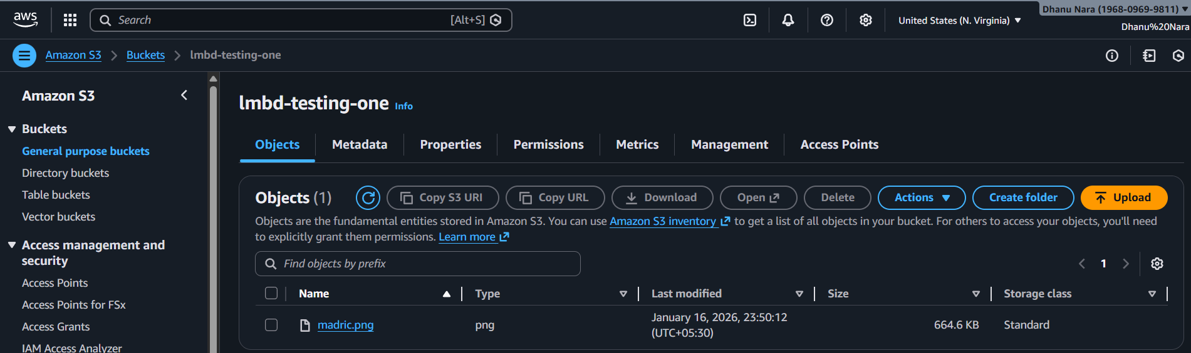
Now the lambda will trigger
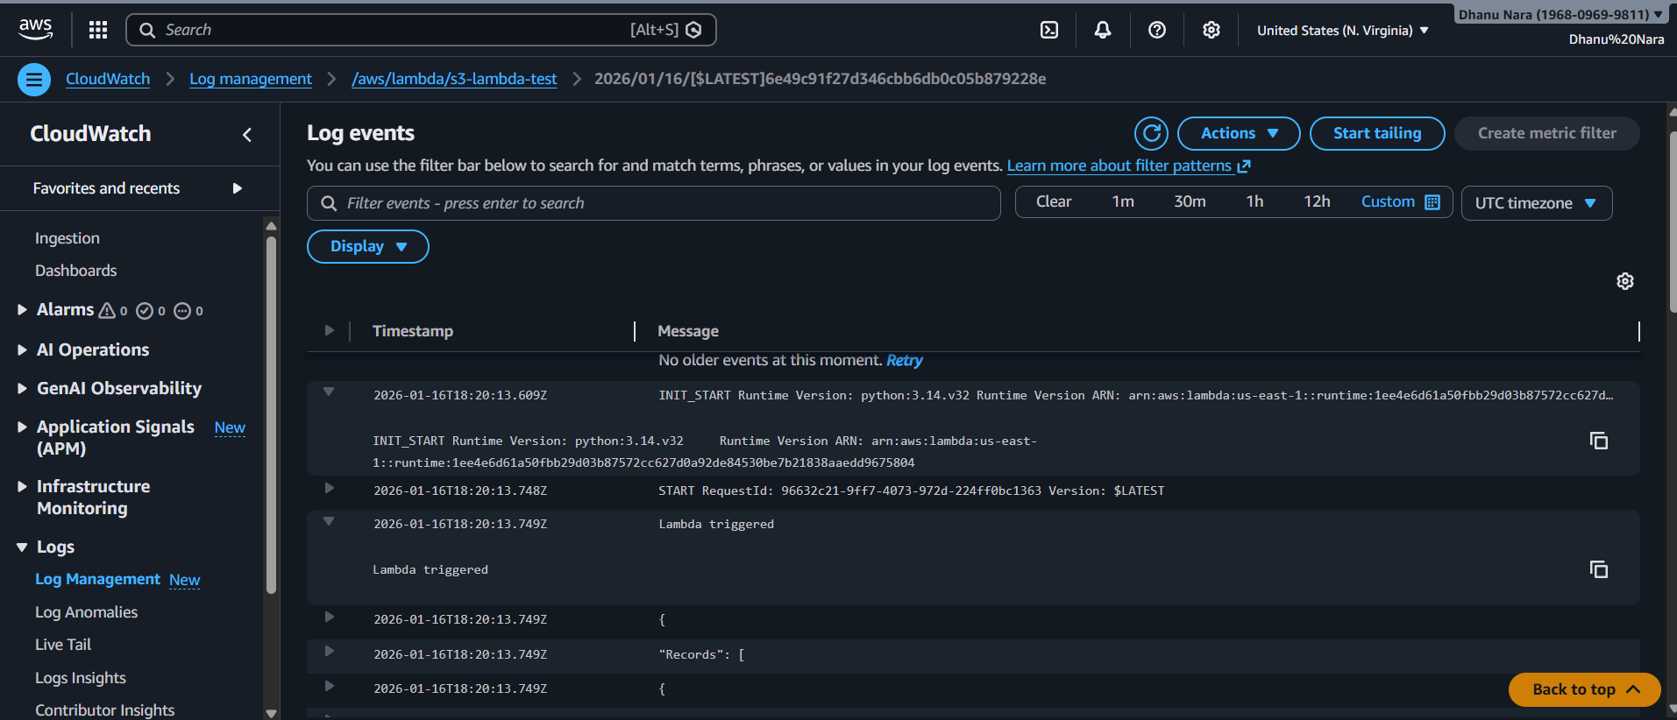

Conclusion
In this task, an AWS Lambda function was successfully integrated with an Amazon S3 bucket using an event trigger. Whenever a file was uploaded to the S3 bucket, the Lambda function was automatically invoked without any manual execution. The Lambda function processed the event data and logged the file details to CloudWatch Logs, demonstrating how serverless, event-driven workflows operate in AWS. This task clearly shows how Lambda reacts to events rather than running continuously, which is a key concept in modern DevOps and serverless architectures.

API-GATEWAY

Title:
Implementing AWS API Gateway with AWS Lambda (HTTP API)

Objective:
To create a serverless HTTP endpoint using AWS API Gateway that invokes an AWS Lambda function and returns a response when accessed through a browser or client.

Prerequisites:
- AWS account
- Basic knowledge of AWS Lambda
- IAM permissions to create Lambda and API Gateway resources
- AWS region selected (us-east-1)
Step-by-step implementation
Step 1: Create a Lambda function
- Open AWS Lambda service
- Click Create function
- Select Author from scratch
- Enter function name as hello-api-lambda
- Choose runtime Python 3.12
- Create a new role with basic Lambda permissions
- Click Create function
- Add the following code and deploy:
- def lambda_handler(event, context):
- return {
- "statusCode": 200,
- "body": "Hello from API Gateway"
- }

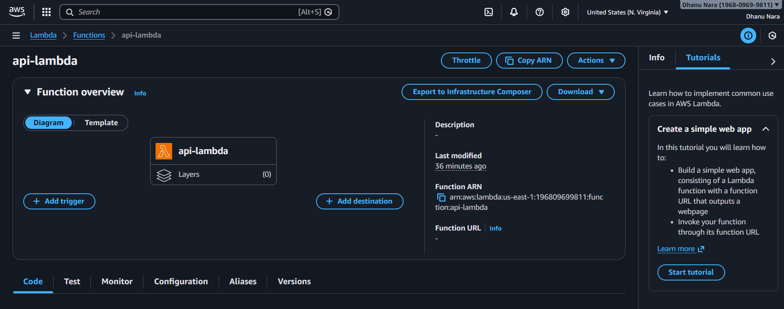
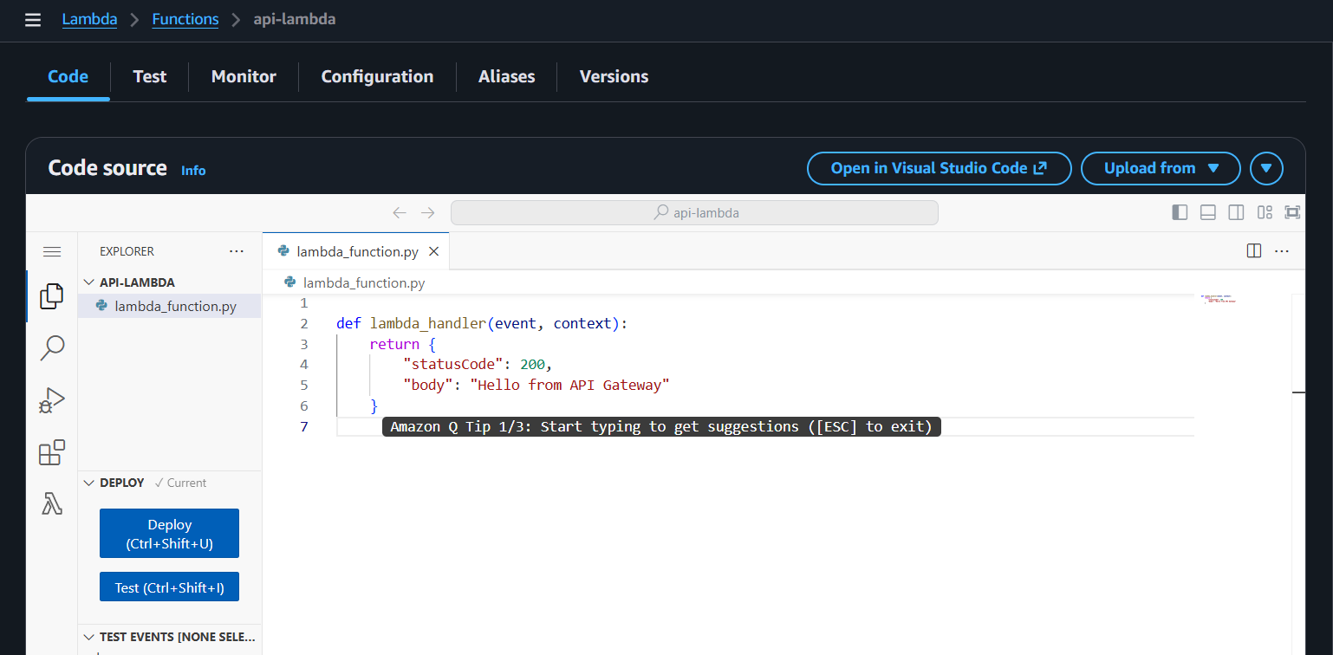

Create an HTTP API
- Open API Gateway
- Click Create API
- Select HTTP API
- Click Build
Configure integration
- Enter API name as api-lambda
- Click Add integration
- Select Lambda function as integration type
- Choose region us-east-1
- Select Lambda function api-lambda
- Click Add
- Click Next

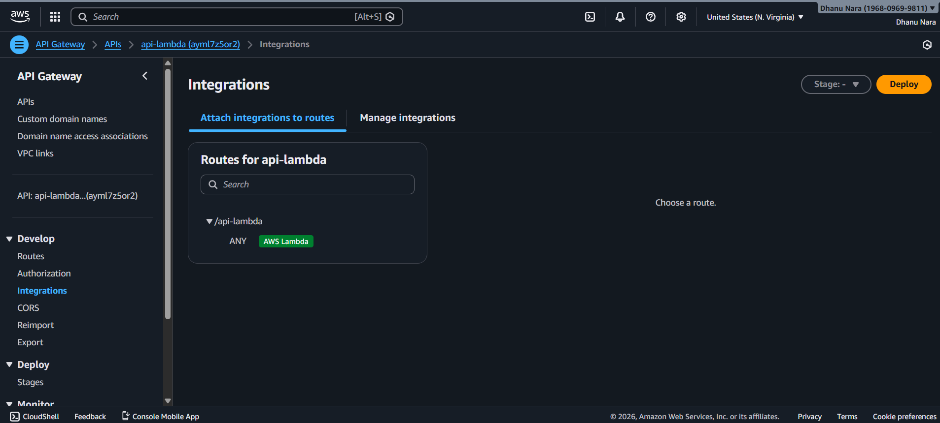
Create and deploy stage
- Create a new stage named newone
- Keep auto-deploy disabled
- Click Create
- Click Deploy and deploy to stage newone

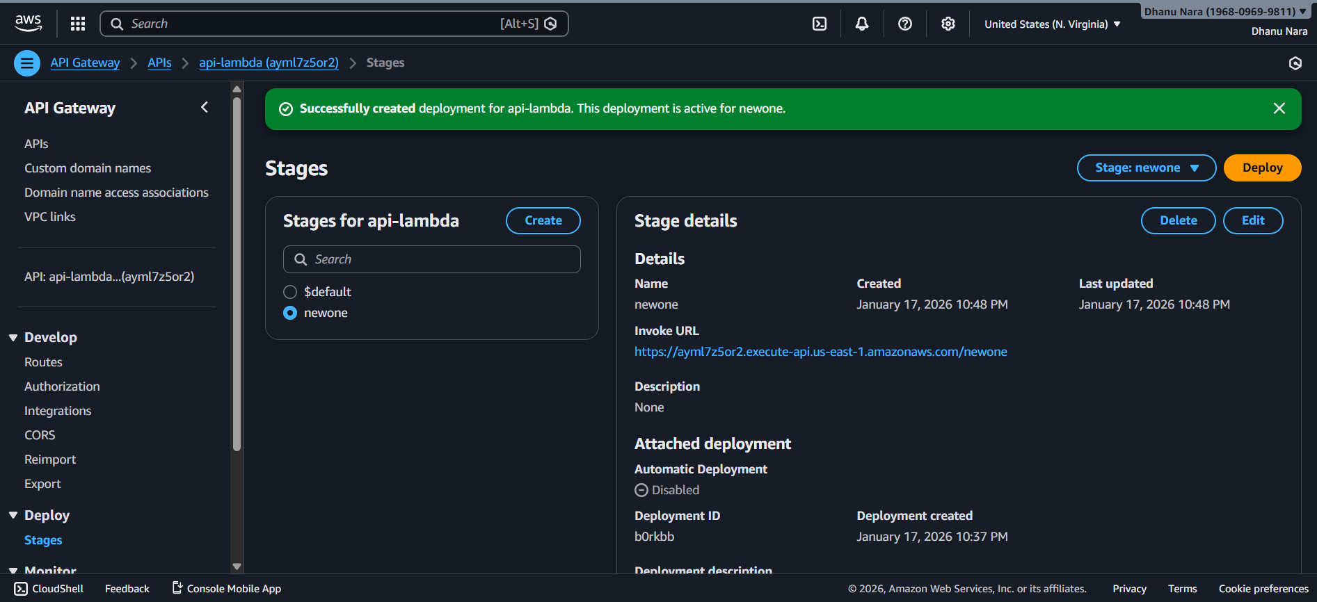
Test the API
- Copy the invoke URL from the stage
- Append the route path /api-lambda
- Open the final URL in a browser

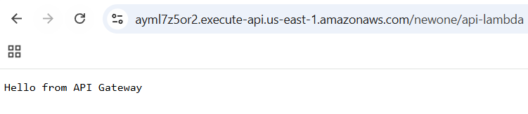
Conclusion
This implementation shows how AWS API Gateway can be integrated with AWS Lambda to build a serverless API. The setup removes the need for server management, automatically scales based on traffic, and is suitable for modern cloud and DevOps applications.

